Drive system

Zixiao Tang (m234547)

Mecanum wheel mobile lift platform, based on mecanum wheel system. This kinds of mobile platform can move forward, sideways and oblique movement. Even zero radius turn movement.

The requirements needed to find the correct motor for the mecanum wheels was done by use of calculating the required torque and thereafter finding a motor which could handle said torque.

The calculations found that in order for the device to move at about 2 Km/h (max), the required torque when crabbing was 13,77 NM and needed an angular velocity of about 52 rad/s. Thereafter it was advised to find a stepper motor for said torque and angular velocity.

The stepper motor which was found was a Bipolar Stepper Motor. This motor was found on stepper online from the following link: https://oceancontrols.com.au/MOT-126.html

In our group design the gearbox needed to connect mecanum wheel and step motor as well. The gear box which was we chosen was ENCONOMIC INLINE PLANETARY GEARBOXES PTN060. This gearbox was found online from the following link: <http://ph.parker.com/au/en/economic-inline-planetary-gearboxes-ptn-series/ptn060-008s7-m060-140-000>.

The steel bracket lets us securely mount typical NEMA 23-size stepper motors and gearbox to our project. The bracket features two slots for various mounting solutions and includes four M4 x16mm screws, washers, and nuts for securing the motor to the bracket. The steel bracket we can’t find the exactly one online to matching our gearbox, So we design it, 65mm long, 60mm wide and 65mm high, 5mm thickness , the picture are showing below.

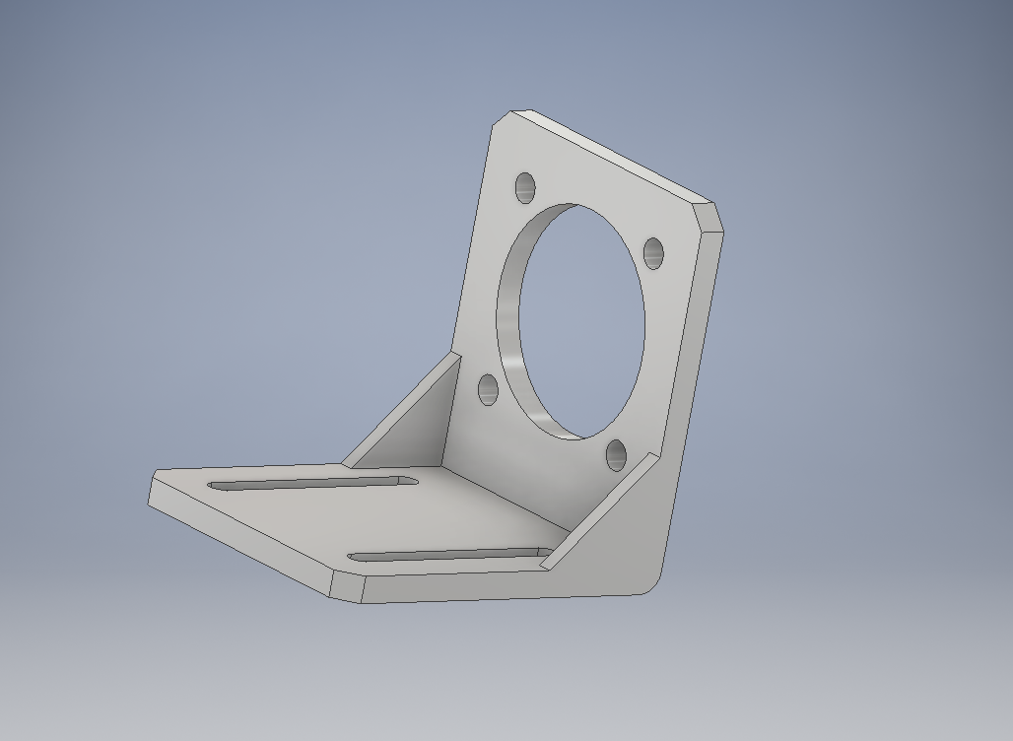

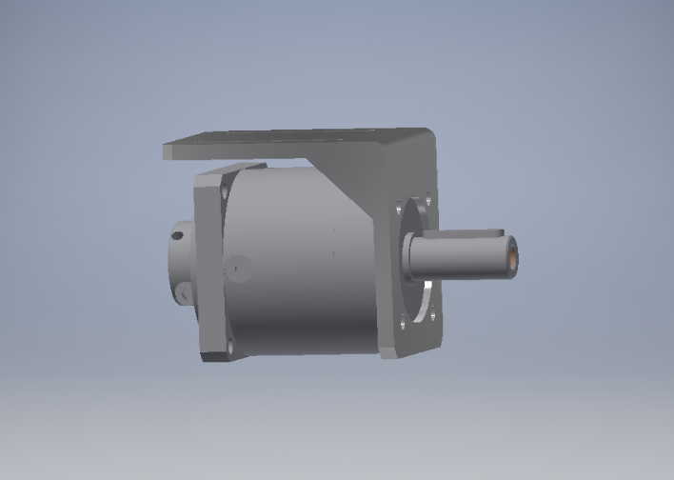

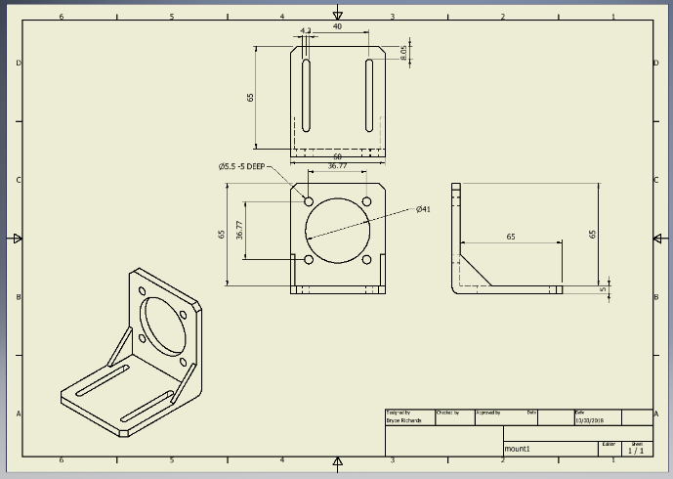

The bracket will be build in workshop.

References: <https://oceancontrols.com.au/MOT-126.html>

<http://ph.parker.com/au/en/economic-inline-planetary-gearboxes-ptn-series/ptn060-008s7-m060-140-000>

<https://oceancontrols.com.au/SMC-007.html>

<https://www.pololu.com/product/2258>